
Welcome to your assessment!
Read this document carefully
It has important information about your assessment.
Contact us if you have questions.
Our contact details
🕿 | Phone | (03) 9478 1333 Northern College of The Arts & Technology
@ | Email | newman.marcus.j@edumail.vic.gov.au  illman.craig.c@edumail.vic.gov.au
Important information about your assessment
Program name | VCE VET Creative and Digital Media
Qualification | CUA31020 - Certificate III in Screen and Media
Task type | This product task comprises of planning, designing and producing a physical product relevant for the workplace.
Task name | Website Production
Unit/s assessed | CUADIG211 - Maintain interactive content
Due date | The week of Wednesday 29th June.
Class time allowed for completion | You will complete this task in class. You can request extra time if needed.
Reasonable Adjustment | Make arrangements with your assessor at least one week prior to the assessment due date if you feel you require special allowance or allowable adjustment to this assessment (e.g. answer questions verbally, more time etc.) You can appeal the assessment decision according to the RTO assessment policy and procedure.
Assessment Conditions | Assessment is conducted on site at NCAT, in a computer lab, running industry software and equipment. Submit completed assessments to the submission folder on studentshared.
Task context | Web design and writing content and copy is common task for a multimedia designer. Updating and maintaining the content, is important for the ongoing success of a website.

Assessment Tasks (a summary)
1 | Plan | You will produce a plan of your website before you begin production.
2 | Website | You will produce a small website using HTML & CSS.
3 | Maintain Interactive Content | You will maintain the content for a broken website.
4 | Evaluation questions | You will answer questions about maintaining interactive content.
Plan

Information and instructions
General information about this activity
Student name |  | Elyssa Egeberg
Assessor name |  | Marcus Newman  Craig Illman
Task title |  | Plan
Unit of competency |  | CUADIG201 – Maintain Interactive Content
Instructions
Student instructions | Designers for multimedia prepare a design document to present to their client, usually as a form of tender, which may or may not be accepted or require further negotiation.  Answer these questions to outline your plan to your trainer. The plan should be between 200 – 300 words.
1 | Name: State your name
1 | Elyssa Egeberg
2 | Job title/project title: Name of your website / topic / client etc.
2 | My Favorite Books Elyssa
3 | Output: Describe what programs you will use and how you will use them.
3 | Unsplash to get images, google fonts to find fonts, goodreads to find the blurb and book cover etc.
4 | Purpose: Describe your concept for the website in one paragraph. Outline the pages and any ‘areas’ of content
4 | My idea is to have a website where I review my favorite books. Each page will be a different book.
5 | Target Audience: Describe in one paragraph. Identify specific groups by some or all the following characteristics: age, gender, socioeconomic status, what their interests are, in work or leisure time, suggest a link to your product or service.
5 | I would say teenage girls or young women that enjoy reading contemporary romance fiction novels. Seeing as they would be these books' target audience.
6 | Confirm how often your website will be updated with trainer
6 | Every week it will be updated
7 | State the due date of this project
7 | 8th of June
8 | Inspiration: Provide screengrabs of any website designs that have inspired you.
8 | 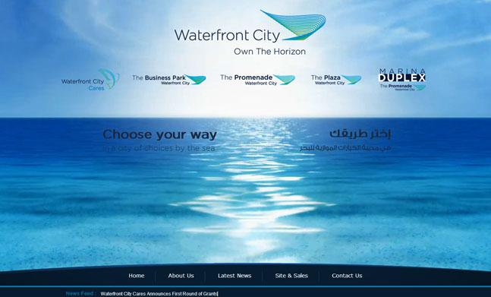  I liked this website it helped me think of how to design my 4th page    this photo gave me the idea for my first page
9 | Evidence of different creative thinking strategies, i.e. Brainstorming, word clouds, etc.
9 | its attached
10 | Storyboards and site maps: Provide storyboards of your website design and a site map of your pages.
10 | its attached
Requirements for satisfactory completion | All evidence must meet the criteria listed.
Assessor instructions | Review the plan, inspiration and storyboards and site map.  Provide feedback to student regarding approval of the plan.  Check website feasibility and appropriateness for audience.  Document the quality of evidence by completing the checklist below.

 |  |  | Assessor to complete these columns ⭢ | Quality of evidence
Evidence to submit |  | Required quality |  | S | NYS
10 | PLAN (Design Brief) | All sections of plan completed |  | ☐ | ☐
11 |  | Successfully prepares website for production |  | ☐ | ☐
12 |  | Submitted to trainer for review |  | ☐ | ☐

Result for this assessment activity
Result |  | Satisfactory |  |  | Not Yet Satisfactory
Assessor comments
Assessor signature |  |  | Date signed

Website

Information and instructions
General information about this activity
Student name
Assessor name | Marcus Newman  Craig Illman
Task title | Website
Unit of competency | CUADIG211 - Maintain interactive content
Instructions
Student instructions | You are to create a 4-page personal website that with working links and graphics. You can choose the topic, but the site must be cohesive in content and design. The website is to adhere to design specifications advised by the relevant personal. (i.e. the trainer.) Submit the website on the due date, with the relevant files. Deliver a visual diary with a documented design process, design document and storyboard. Negotiate final concept / designs with your trainer. Use Dreamweaver as your authoring tool to produce a working website using HTML & CSS. You will use Adobe Photoshop to add graphics to your site. You can use other programs if negotiated with trainer.
Student instructions | REQUIREMENTS AND TECHNICAL SPECIFICATIONS  Requirements and Technical specifications can be negotiated with trainer.
Student instructions | The website must include CSS.
Student instructions | 4 - 6 pages which contain links
Student instructions | Must contain 1 link to an external website
Student instructions | Must contain 1 link to an email address
Student instructions | Must contain digitally manipulated photo images either created in Photoshop or edited using Photoshop
Student instructions | Must contain at least one body of text with two paragraphs
Student instructions | Use of visual design elements and principles
Student instructions | Use of C.A.R.P. principles
Student instructions | Evidence of any problems solving through annotation in visual diary.
Whast is the GITHUB.IO address of your website?
Requirements for satisfactory completion | You must meet all criteria below when conducting the session
Assessor instructions | Assessors provide feedback on production and check quality of the production plan using the checklist below.
 |  |  | Assessor to complete these columns ⭢ | Quality of evidence
Evidence to submit |  | Required quality |  | S | NYS
1 | PRODUCT | Meets the intended design/requirements as outlined in the plan |  | ☐ | ☐
2 |  | Functions effectively as website |  | ☐ | ☐
3 |  | Contains requirements |  | ☐ | ☐
4 |  | Meets technical specifications |  | ☐ | ☐
5 |  | Contains no copyright issues |  | ☐ | ☐
6 |  | Upload to submission folder in studentshared.

Result for this assessment activity
Result |  | Satisfactory |  |  | Not Yet Satisfactory
Assessor comments
Assessor signature |  |  | Date signed
Maintain Interactive Content

Information and instructions
General information about this activity
Student name
Assessor name |  |  | Marcus Newman  Craig Illman
Unit of competency |  |  | CUADIG211 - Maintain interactive content
Due Date |  |  | Tuesday 14th May
Instructions
Context |  |  | Maintenance generally means making sure that your files and file directory structure are up and running properly at all times, and your links are functional. Since HTML documents and their related graphics or additions that your make to existing file names or directories could alter their relationship to another. The most common result is that links are broken, and images or entire pages don’t load properly. In this test, you are required to follow instructions and respond to the client’s requests to update and maintain their website.  “Dear Web Designer,  Something went down with our server and our website is messed up.  Can you fix it thanks?  Deadmau5.  Head of mau5trap.
Student instructions |  |  | The trainer will direct you to the files you will need to maintain and update the website. Correct any errors as directed on this sheet and any others you might find throughout.
Requirements for satisfactory completion |  |  | Maintain the website to working order by following the instructions.
Assessor instructions |  |  | Assessors please check the completed website and provide feedback.
Please make changes to each page. Tick when complete. ✓
CSS |  |  |  |  |  |  |  |  | COMPLETE
1 | Read the context, obtain the content and manage the site in Dreamweaver. |  |  |  |  |  |  |  | ☐
2 | Open index.html and navigate to style.css |  |  |  |  |  |  |  | ☐
3 | Find background-image: url(BG.jpg) in the css. replace with BG.jpg with BG_Deadmau5.jpg. |  |  |  |  |  |  |  | ☐
4 | Change the colour of footer to whitesmoke; Remember colour is written in the American spelling. |  |  |  |  |  |  |  | ☐
5 | Find nav a:hover { background-color: and change greenyellow; to deeppink; |  |  |  |  |  |  |  | ☐
6 | Change the fontsize of <h2> to 30 px. |  |  |  |  |  |  |  | ☐
7 | Change the fontsize of <h1> to 50 px. Change the colour to white. |  |  |  |  |  |  |  | ☐
INDEX.HTML
8 | In the <head> change the <title> to <title>mau5trap</title> |  |  |  |  |  |  |  | ☐
9 | Check all the links in the menu. If any are broken fix them. |  |  |  |  |  |  |  | ☐
10 | Add the following text below the <h1> heading Who We Are. mau5trap is deadmau5's own label and has been the home to some of the biggest electronic music released in the last 9 years. |  |  |  |  |  |  |  | ☐
11 | Remove the paragraph <p> tags and change the HTML code to display the artists as a list <li>. Make sure the list is unordered <ul>. |  |  |  |  |  |  |  | ☐
12 | Edit the html in the merch article to reflect:  <img src="MAUShirt.png" alt="Deadmau5 Shirt” class="center"> |  |  |  |  |  |  |  | ☐
13 | Link the word here to https://mau5trapmerch.com/ |  |  |  |  |  |  |  | ☐
DEADMAUS.HTML
14 | Insert in the Deadmau5.jpg underneath the Deadmau5 <h2> heading. Make sure it has an <alt> tag. |  |  |  |  |  |  |  | ☐  ☐
15 | Add the following text below the About <h2> heading with a <p> paragraph tag.  Joel Thomas Zimmerman, known professionally as Deadmau5, is a Canadian electronic music producer, DJ, musician, and composer. Zimmerman produces a variety of styles within the progressive house genre and sometimes other forms of electronic music. |  |  |  |  |  |  |  | ☐
16 | Change the Selected Albums heading from <h1> to <h2>. |  |  |  |  |  |  |  | ☐
17 | Remove <p> tags and make the Selected Albums into an ordered list. <ol> |  |  |  |  |  |  |  | ☐
REZZ.HTML
18 | Change <h2> Deadmau5 heading to Rezz. |  |  |  |  |  |  |  | ☐
19 | Investigate why the image is not RezzWEB.jpg is showing a broken image icon. Fix this issue. Make sure it has a <alt> tag. |  |  |  |  |  |  |  | ☐
20 | Add the following text below the About <h2> heading.  Isabelle Rezazadeh, born May 28, 1995, better known as Rezz, is an electronic music producer from Niagara Falls, Ontario. In 2015, Rezz released her first EP, Insurrection , through Nest HQ. She followed in 2016 with releases off deadmau5's label mau5trap with The Silence is Deafening and Something's Wrong Here. |  |  |  |  |  |  |  | ☐
21 | Change the Selected Tracks heading from <h1> to <h2>. |  |  |  |  |  |  |  | ☐
22 | Change the ordered list into an unordered list. |  |  |  |  |  |  |  | ☐
CONTACT.HTML
23 | Create a new article item and close the tag. |  |  |  |  |  |  |  | ☐
24 | Check all the links in the menu. If any are broken fix them. |  |  |  |  |  |  |  | ☐
25 | In-between the article, create a new <h2> heading tag that reads Contact Us and close the tag. |  |  |  |  |  |  |  | ☐
26 | Create a new <p> paragraph tag that reads Want to send us a demo? and close the tag. |  |  |  |  |  |  |  | ☐
27 | Create a new <p> paragraph tag that reads Email joel@mau5trap and close the tag. |  |  |  |  |  |  |  | ☐
28 | Add the mailto:joel@mau5trap to make an email link |  |  |  |  |  |  |  | ☐
29 | Make sure all tags a closed. |  |  |  |  |  |  |  | ☐
30 | Test all pages, check all content is being displayed correctly and confirm all changes with the trainer. Upload to submission folder in studentshared. |  |  |  |  |  |  |  | ☐
VISUAL GUIDES
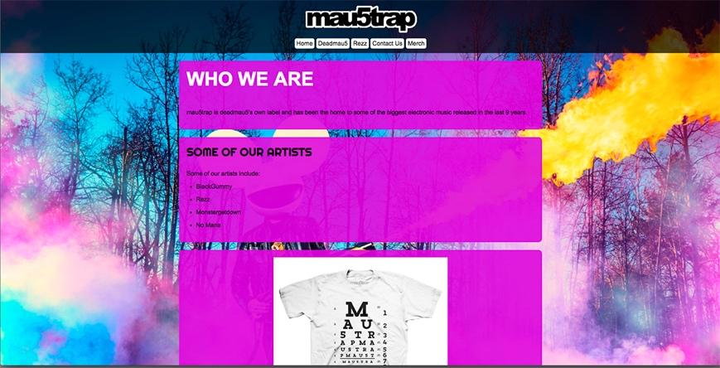
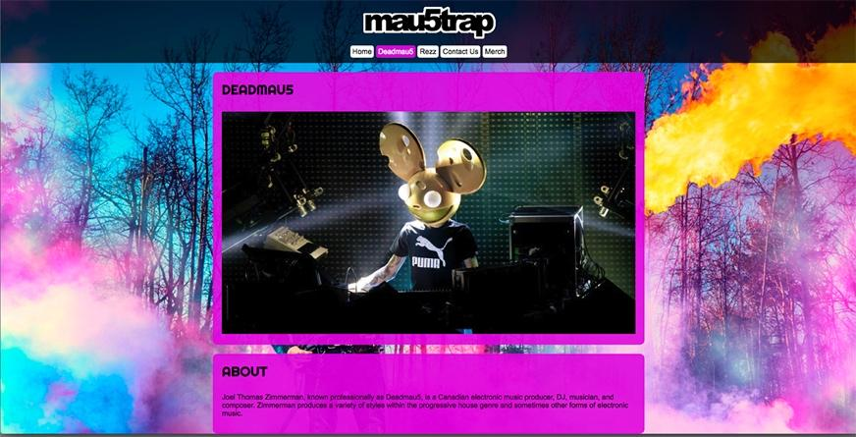
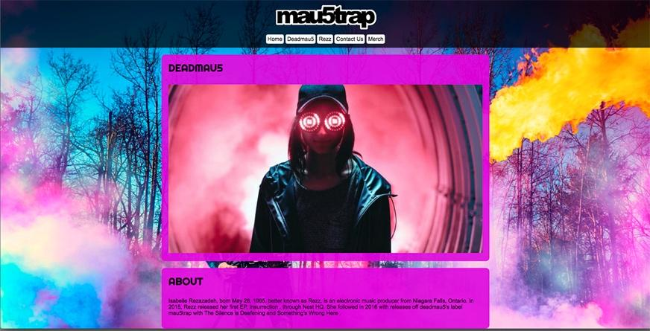
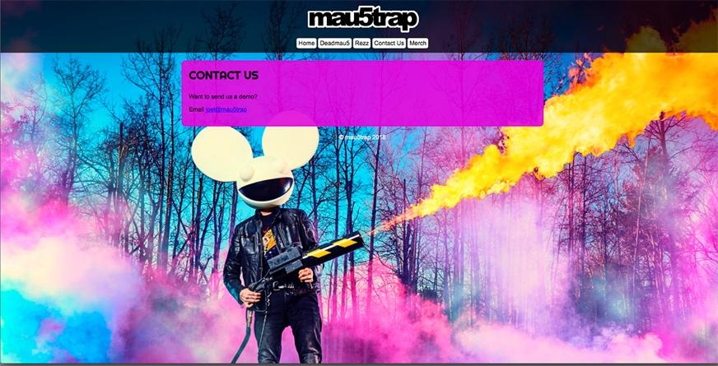

Result for this assessment activity
Result |  |  |  | Satisfactory |  |  | Not Yet Satisfactory
Assessor comments
Assessor signature |  |  |  |  | Date signed
Evaluation Questions

Information and instructions
General information about this assessment activity
Unit of competency | CUADIG211 - Maintain interactive content
Student name
Due date
Instructions
Student instructions | When you have completed the task answer these questions about maintaining a website.
Requirements for satisfactory completion | All questions must be answered correctly.
Assessor instructions | Assessors, please supervise students and check answers are correct.

Open questions
Answer the following questions:
1 | How do outdated or broken links impact on the usability of a web site?
2 | If you wish to include someone else’s image in your own work, what do you need to do?
3 | What is the purpose of an alt tag?
4 | How does an alt tag help your website to be more accessible?
5 | Why should a website be updated often?
6 | Describe some of the changes you had to make when maintaining the deadmau5 website.
7 | What metadata tags did you apply?
8 | Describe safe practices when working on computers for a long time:

Result for this assessment activity
Result | ☐ | Satisfactory |  | ☐ | Not Yet Satisfactory
Assessor comments
Assessor signature |  |  | Date signed

Assessment Coversheet
General information
RTO Name | Northern College of The Arts & Technology
School Name | Northern College of The Arts & Technology
Unit/s assessed | CUADIG211 - Maintain interactive content
Task | Web Design
STUDENT to complete this section
Name
Email
Date submitted
Student declaration—By signing below, I declare that:
⚫ I have been advised of the assessment requirements, have been made aware of my rights and responsibilities as an assessment student, and choose to be assessed at this time
⚫ this portfolio contains my own work except where I have made due reference to work by other/s. I am aware that a false declaration may lead to withdrawal of a qualification or statement of attainment.
Student signature* |  |  |  | Date signed
* Student must provide a REAL signature. If submitting your portfolio electronically, either insert an electronic signature in the space above, or print this page, sign it, then submit a scan of the signed page.
ASSESSOR to complete this section
Name of assessor
Date assessment received
Date assessment review completed

